Example Micro-Challenge Memo (Partial)

This example illustrates a standard memo with proper headings (circled below) and starts with a memo purpose. The tasks in the memo are numbered and answered in sequence. Each written response starts with a brief restatement of the task which is followed by a thorough and accurate response supported with an image and associated weblink. The image is present in the memo, visible and legible.

TO: My Manager

FROM: _____________ – Assistant International Trade Specialist

DATE: June 4, 2022

SUBJECT: Information Sources about _____________

This memo identifies and summarizes information about the country of _____________ from a variety of sources that may prove helpful for international trade efforts. The information may aid in decision-making with regard to international trade with _____________. The four tasks I was assigned are addressed sequentially below.

1. Four US governmental resources about _____________ were reviewed. A brief description, summary, image, and weblink are provided for each.

A. The International Trade Administration has a Country Commercial Guide for _____________. This resource provides information about . . . .

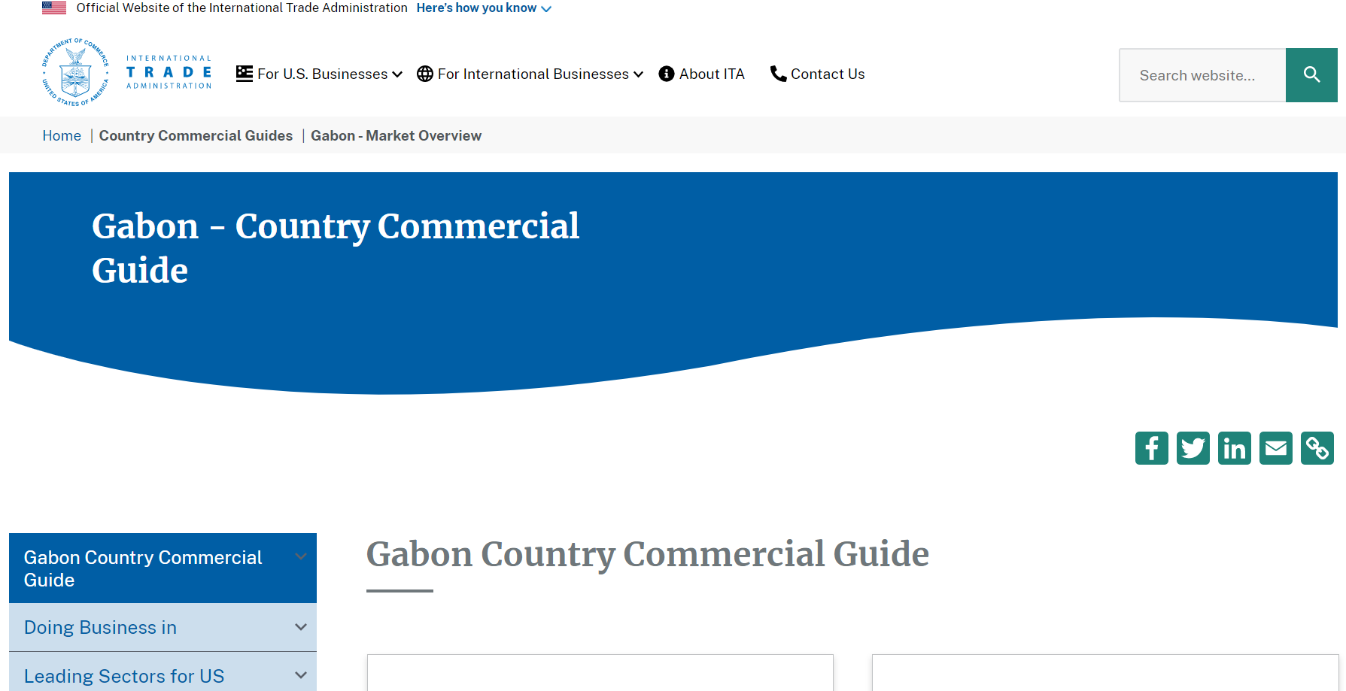
Weblink: https://www.trade.gov/country-commercial-guides/gabon-market-overview?section-nav=10574

B. The office of the US Trade Representative provides a document called the 2018 National Trade Estimate Report on FOREIGN TRADE BARRIERS which provides information regarding _____________ for _____________.

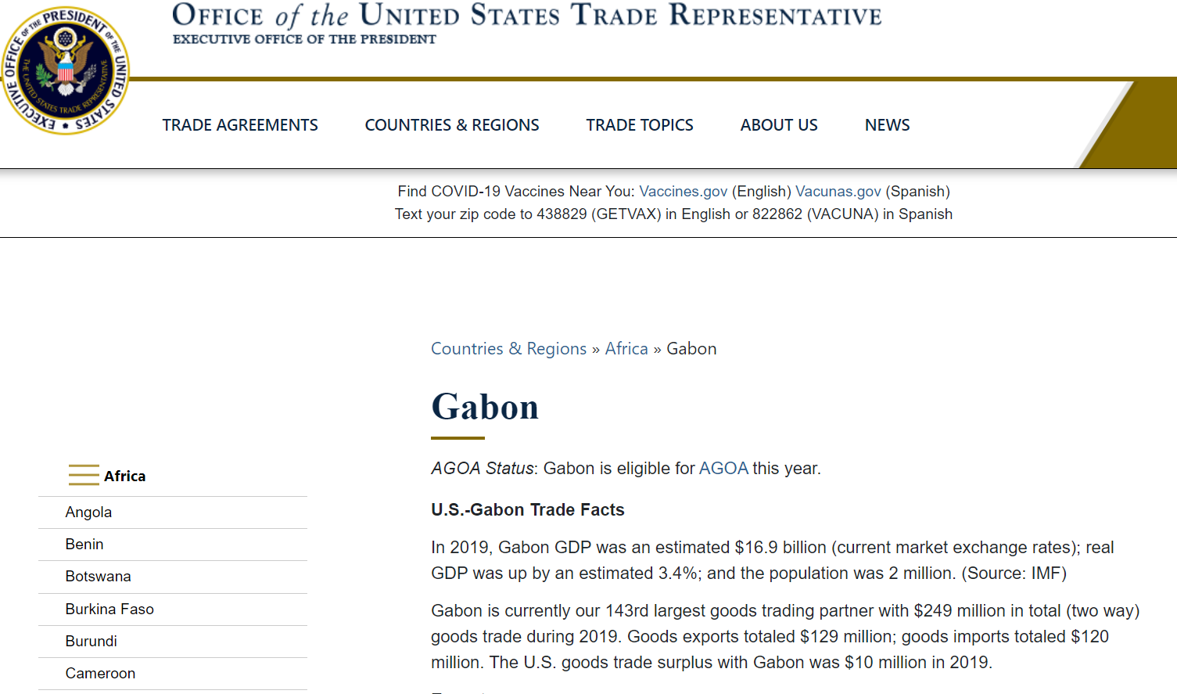
Weblink: https://ustr.gov/countries-regions/africa/central-africa/gabon

etc.,

